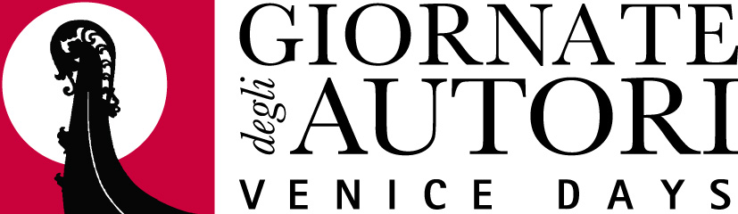

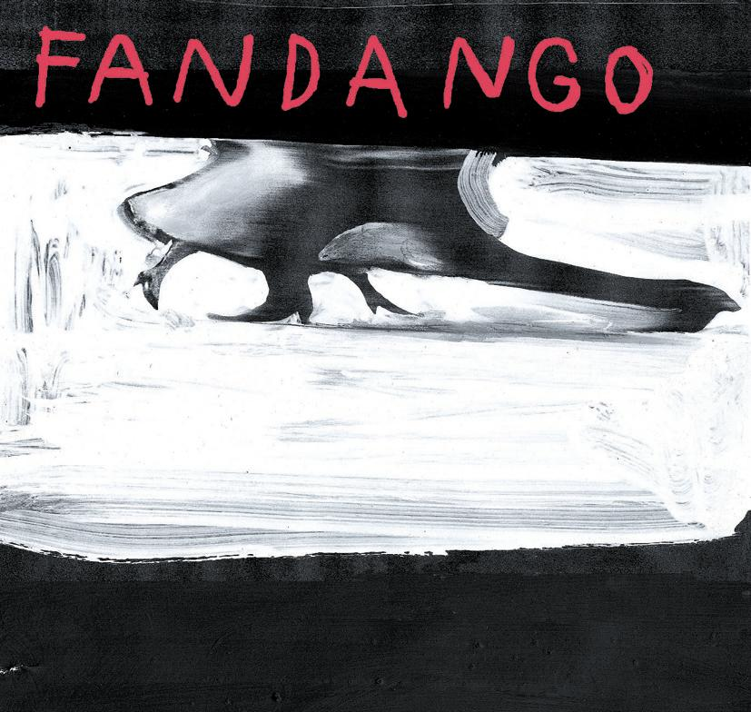


DOMENICO PROCACCI
GIANLUCA ARCOPINTO PIERPAOLO TREZZINI
Present

CHANGING DESTINY

(NEMMENO IL DESTINO)

based on the novel by
Gianfranco Bettin “Nemmeno il destino” (“Not Even Destiny”)
Edizioni Feltrinelli

“And of all the fires that die in me
There’s one burns like the sun
It might not make day my personal life
My association with people
Or my behaviour towards society
But it all does tell me my soul has a shadow.”
Gregory Corso
Writ on the Eve of My 32nd Birthday

a film by

DANIELE GAGLIANONE

a

FANDANGO

ARMADILLO

production

International Sales
THE WORKS
Tel. +44(0) 20 7612 1080

Fax.+44(0) 20 7612 1081

Distribution for Italy

FANDANGO

FANDANGO PRESS OFFICE
DANIELA STAFFA (+39) 335.1337630
MARINELLA DI ROSA (+39) 335.7612295
Tel. (+39) 06.97745006 - Fax (+39) 06.97745020
e-mail: ufficiostampa@fandango.it

Crew

DIRECTOR DANIELE GAGLIANONE
SCREENPLAY GIAIME ALONGE
DANIELE GAGLIANONE
ALESSANDRO SCIPPA

DIRECTOR OF PHOTOGRAPHY GHERARDO GOSSI
PRODUCTION DESIGN VALENTINA FERRONI
COSTUMES MARINA ROBERTI
MUSIC GIUSEPPE NAPOLI
EDITING LUCA GASPARINI

SOUND GIANLUCA COSTAMAGNA

EXECUTIVE PRODUCTION PABLO

PRODUCED BY DOMENICO PROCACCI
GIANLUCA ARCOPINTO
PIERPAOLO TREZZINI

PRODUCTION FANDANGO
ARMADILLO

ITALY 2004
COLOUR
LENGTH: 110’
FORMAT: 1,85

Cast

Alessandro Stellin MAURO CORDELLA
Ferdi Castronovo FABRIZIO NICASTRO
Toni GIUSEPPE SANNA
Adele Stellin LALLI
Young Adele PALMA DI NUMMO
Sebastiano Castronovo GINO LANA
Lorenzo STEFANO CASSETTI

Synopsis

“Changing Destiny” is a story about the outskirts: those of the city and of the soul. The two young protagonists, Alessandro and Ferdi are school friends who live in a decaying post-industrial city, which is being ravaged by construction companies. Alessandro and Ferdi are searching for their place in the world – an oasis amongst the rubble. The rubble is also that of their broken families. Alessandro is the son of an unwed mother who in spite of her efforts to lead a normal life appears ever more the prisoner of her painful past. Ferdi lives with his father, an ex-workman who has turned to the bottle.

Instinctively the pair try to escape their fate and the defeated world of their parents. But their attempts to save themselves end repeatedly in tragedy. This is a story of painful growing up but also of courageous reconciliation with life through rebellion.

This film is for all those people who have lost themselves forever; for those who have lost themselves and found themselves; for all the friends made at that age when becoming friends is instinctive; for all the parents and children who understood each other too late; and for those who can’t take it, who think that there must be another place to conquer. It is an angry elegy, a sob shouted out, a silent mute scream against the ghosts of the past and the monsters of the present.
- Daniele Gaglianone -

Taken from the afterword of the novel “Nemmeno il destino” (English title: “Not Even Destiny”) by Gianfranco Bettin:

“…Aside from reading others (critics etc), another encounter made me think again about the text so that I could discover elements that were unfinished, or distorted, in the first edition, which needed adjustment or cutting or, on the contrary, stressing. I refer to my encounter with Daniele Gaglianone, the director of Our Years, a beautiful film that moves between yesterday and today, between partisan and our present-day experience, with a strongly innovative language yet with classic intensity and expressive strength. Gaglianone made his new film from Nemmeno il destino [Changing Destiny], to be released soon, and it is thanks to him that I understood my text better, also discovering in the story a singular correspondence and relationship with his version. For example, at a certain point in the film, one of the characters – Ferdi – is looking through a book he took out of the school library, attracted by the title. The book is The Sound and the Fury, which is one of my guide books in general and for this novel in particular (and by coincidence, exactly the edition used in the film, the old one published by Medusa Mondatori). Originally, along with the quotation from Andrea Zanzotto, Nemmeno il destino opened with a quotation taken from Faulkner’s great novel. Then, at the very last moment, I removed it, being a little ashamed at suggesting daring and untenable relationships between the two texts… (I quoted a verse of poetry from Zanzotto: no danger of a hint to a claim of relationship). Gaglianone didn’t have this qualm, and he did well, because tributes must not be paid when those paying them blush before the creditor.”

- Gianfranco Bettin -
“Universale Economica Feltrinelli” publications

DANIELE GAGLIANONE
Director

Born in Ancona on 4 November 1966, Daniele Gaglianone received his degree in Modern Literature from the University of Turin, a degree course in Film History and Critic with Professor Gianni Rondolino. Since 1991 he has been collaborating with the Turin Archivio Nazionale Cinematografico della Resistenza (ANCR) (National Cinema Archive of the Resistance).

Filmography

2001 Gaglianone made his first feature film Our Years, which was presented at the Quinzaine des Réalisateurs in Cannes and won numerous awards including the “Sacher d’oro” award for best first work, award for best leading actors at the Valencia Film Festival, award for Best Film at the Festival of Italian Cinema at Villerupt, award for the Best Film at the International Mountain Cinema Festival in Autran and also won the Cultural Review Lo Straniero award directed by Goffredo Fofi.

2000 Tutti mi chiedono da dove vengo - nessuno vuol sapere chi sono (video, short) co-authors Monica Affatato, Luciano D'Onofrio

1998 Screenplay collaborator and assistant director for the film by Gianni Amelio The Way We Laughed, Golden Lion at the 55th Venice Festival.
Vratite se (video, mm) made during the Sarajevo Workshop, September-October 1998.
Torino, una città si accende; co-director with Pietro Balla, Giuseppe Selva, Alberto Signetto, Enrico Verra; made for Rai3 and broadcast on 28 November 1998.
He formed the theatrical group ILBUIOFUORI where he staged the shows Aggrappati ad una terra rivoltata sull'abisso and Sarebbe un sogno d’oro.
Un inverno invisibile(video, short) co-author Monica Affatato

1997 Participated in the Biennial of Young Mediterranean Artists in Turin, where he presented L'orecchio ferito del piccolo comandante and La carne sulle ossa.
With the same works he participated in the Biennial of Rijeka where he received First Prize at the Biennial from the international jury.
Antonio Gramsci. Gli anni torinesi (video, short, for the ANCR), co-author Alessandro Amaducci, tied for 1st place at Videoland 1998).

1996 La carne sulle ossa (video, short) Prize for best story at the Festival of Civitanova Marche 1997
Luoghi inagibili in attesa di ristrutturazione capitale (video, short, 1st Prize Spazio Italia non fiction at the 15th Festival Cinema Giovani of Turin)

1996 Collaborated on the video programme Le stagioni della Resistenza in 10 set-ups and a prologue managed by Paolo Gobetti, making 6 of the 11 parts of the project: “8 settembre”, “Ribelli”, “La violenza nemica”, “Insurrezione e liberazione”, “I lanci alleati” (co-author Alessandro Amaducci), “Azioni e colpi di mano” (co-author Alessandro Amaducci)
Cinecronache partigiane, co-author Alessandro Amaducci (video, short, for the ANCR)

1995 Cichero (video, mm, for the ANCR) 1st prize Italian Documentary Festival “Libero Bizzarri”
E finisce così (16mm. short)
Il vento fra le mani - la violenza nemica (video, short) special mention at Preview of Independent Italian Cinema in Bellaria

1994 L'orecchio ferito del piccolo comandante (16mm. short) selected for the 40th Kurtztilmtage in Operhausen; special mention at the Locarno Festival 1995, "Pardi di domani" section; 1st prize at the 11th Festival of Mediterranean Cinema in Bastia 1995
Il sale della terra (16mm. short)
Quel fare che inventa (mentre fa) il modo di fare (video, short)
Lancia di Chivasso: una comunità operaia non rassegnata (video, 60', for the ANCR)

1993 La battaglia della ferrovia (video, short, for the ANCR)
Sparare a vista sul sovversivo Agosti (video, short, for the ANCR)

1992 Mario Soldati e il cinema (video, short film, for the ANCR.
Alla ricerca di Piero Gobetti (video, short, for the ANCR)
Era meglio morire da piccoli (video, short) 1st prize at the 10th Festival Cinema Giovane, selected for the 39th Kurtztilmtage in Openhausen

1991 La ferita (video, cm) 2nd prize at the 9th Festival Cinema Giovane

MAURO CORDELLA
‘Alessandro Stellin’

FABRIZIO NICASTRO
‘Ferdi Castronovo’

GIUSEPPE SANNA
‘Toni’

Cordella, Nicastro and Sanna’s make their feature film debuts in “Changing Destiny”.

LALLI
‘Adele Stellin’

1998
Lalli made her first work under her real name, the CD Tempo di Vento, for per Il Manifesto publishers. The album was received successfully by both critics and public – about 10,000 copies sold – so much so that the specialised magazine Rockerilla called it the best Italian rock disk of 1998. Tempo di Vento also received the Fuori dal Mucchio Award, set up by the magazine Il Mucchio Selvaggio, as best debuting Italian disk in 1999.

Lalli is anything but a beginner. In the past she was the voice of the Franti, legendary Turinese project group of the 80’s. With Stefano Giaccone, another Franti member, she gave life to quite a few experiences (Environs, Orsi Lucille, Howth Castle, Ishi).

1999
In July Lalli concluded the mini-CD titled Tra le dune di qui, produced by Beware!, independent label of Spotorno.
The disk had two new songs, Tra le dune di qui and Terra vista dalla Luna, which won her the Special Jury Award in the 5th national competition of original music dedicated to the Livornese singer-songwriter Piero Ciampi.

2000
She wrote a new piece together with the musician Pietro Salizzoni, Testa storta, specially composed for the sound track of Mimmo Calopresti’s film, I Prefer the Sound of the Sea.

2001-2002
Lalli later received an invitation to participate in the 23rd prestigious Turin Festival Settembre Musica and the 2001-2002 season was nearly entirely dedicated to theatre concerts.

Lalli was also involved in a parallel musical project as interpreter, along with the Argentinean guitarist Miguel Angel Acosta, from the show Vengo a ofrecer mi corazon, a tribute to the free singers of the South American land, such as Atahualpa Yupanqui, Violeta Parra, Leon Gieco and others, a show put on also at London’s Spitz club. Here she consolidated her collaboration with the musician Pietro Salizzoni for writing new songs and with whom she shared the project and realisation of the new disk All’improvviso, nella mia stanza, the release of which was again entrusted to the Manifesto’s Edizioni musicali. There is something reminiscent in this of previous works, even though quite different, above all in the sonority, found also in the repertory of ethnic, folkloristic and popular music. The intention was to give lightness and breath again to stories told, hoping that the songs would give them visibility, space, time, even though surely not justice. Aside from the work, commitment and dedication of all the musicians who for one reason or another participated in making this new CD, and aside from Pietro Salizzoni’s attentive artistic production, the precious collaboration with Carlo U. Rossi turned out to be fundamental for putting this sound photography truly in focus. Rossi is a Turin producer who worked previously with Mau Mau, Capossela, Subsonica and many other artists.

In Lalli’s latest musical project she “lent” her voice to some songs of the debuting soloist Massimo Zamboni Sorella sconfitta, recently released for RadioFandango.

In 2003 she committed herself to “Changing Destiny” by Daniele Gaglianone.

STEFANO CASSETTI
‘Lorenzo’

2003 Nord Est - il vecchio e il cinese directed by Rodolfo Bisatti

Changing Destiny directed by Daniele Gaglianone

2002 Michel Vaillant directed by L. Pascal Couvelaire
Nomination for Most Promising Actor César 2002

Sulla Mia Pelle directed by Valerio Jalongo

Turin Film Festival 2003

2001 Roberto Succo directed by Cedric Kahn

In competition at the 2001Cannes Film Festival

GHERARDO GOSSI
Director of Photography

Gherardo Gossi was born in Turin on 24 January 1958. A professional since 1981, he worked as director of photography for production companies in Rome, Milan and Turin making feature films for cinema, television, publicity, documentaries for television and industry, video clips. He speaks English and French fluently.

Filmography

2004 Radio Alice directed by Guido Chiesa
Changing Destiny directed by Daniele Gaglianone

2003 Now or Never directed by Lucio Pellegrini
56th Locarno internationa l Film Festival

- Maximum Velocity directed by Daniele Vicari
59th international film festival of Venice
David di Donatello for best debuting director 2003

2001 From Zero to Ten directed by Luciano Ligabue
“Semaine de la critique” Cannes 2002

2000 Our Years directed by Daniele Gaglianone
“Quinzaine des realizateurs” Cannes 2001
18th Turin Film Festival
Johnny the Partisan directed by Guido Chiesa
57th international Film Festival of Venice

1999 Non mi basta mai directed by Guido Chiesa and
Cipputi award 17th Turin Film Festival Daniele Vicari

1998 Benvenuti in S. Salvario directed by E. Verra
European Academy Award "Felix 1999"
Short film festival Clermont Ferrand 1999
Rose directed by Abramo and Bertoni

1997 Partisans directed by Chiesa, Leotti, Ferrario, Puccioni, Vicari
Border line by I. Maria and G. Gebbia

1996 Materiale resistente directed by D. Ferrario and G. 49th international festival of Locarno Chiesa
Chiuso per lutto directed by N. Dondolino

1995 No man’s Land directed by E. Verra

1994 Anime fiammeggianti directed by D. Ferrario
51st Venice Film Festival
Sundance Film Festival 1996
Babylon: Lies to Live by directed by Guido Chiesa
47°. festival internazionale di Locarno
FIPRESCI International Cinema Giovane Festival Award

1992 Il tempo dei sogni directed by Guido Chiesa

1991 Il caso Martello directed by Guido Chiesa
Grolla d’Oro 1991 best directing debut
48th Venice Film Festival
La raccomandazione directed by A. Leotti
Special mention 9th Cinema Giovane Festival
Il sacrificio directed by I. Spinelli

1989/1990 The Thing (Turin) directed by Nanni Moretti
1988 Morgen directed by L.Moisio A.Baricco
1984 Vita spericolata directed by L.Moisio A.Baricco Special mention at the Cinema Giovane Festival

Best photography “FILMSELEZIONE 1998" for:

BULGARI pelle directed by R.Rinetti
La Reggia dei pitti directed by P.Abbati
BRACCO Istituzionale directed by M.Canci

Made musical clips for: BMG, POLYGRAM, WEA and independent producers. Latest production:
C.Consoli, L.Ligabue Questa è la mia vita directed by Richard Lowenstein

Television

Alice e’ in Paradiso directed by G.Chiesa prod. FANDANGO for TELE+

Una questione privata directed by G.Chiesa prod. PALOMAR for RAI 2
Un giorno di fuoco directed by G.Chiesa prod. POLYGRAM VIDEO
Giardini d’Italia directed by P.Martin in HD prod. EUPHON MI and BBC
Davvero from THE REAL WORLD – MTV format prod. PALOMAR for RAI DUE
Great Moments Of Italian Art directed by P.Martin in H.D. coprod. NHK / EUPHON
Il tempo delle scelte directed by B.A.Raffanini RAI UNO
New Model Today directed by B.A.Raffanini RAI DUE
Storie Vere directed by Ercolani and Calopresti RAI TRE
Civilta 13 episodes directed by Buttafarro, Calopresti RAI SAT
Chiesa, Ferrario, Guaschino, Leotti

Giuseppe Napoli
Music

Guiseppe Napoli was born in Canelli (Asti) on 21 September 1965. He received a degree in Ethnomusicology from D.A.M.S. in Bologna and later a diploma in Sound Technology from the Centro Sperimentale di Cinematografia in Rome. After collaborating as bass player and on the keyboard with many rock groups in the Turin area (among others Fratelli di Soledad), in 1991 he dedicated himself predominantly to composing music for film. He was responsible for the music in films by Guido Chiesa (Il caso Martello, Babylon, Non mi basta mai – this latter co-directed with Daniele Vicari), Daniele Segre (Manila Paloma Blanca), Nicola Rondolino (Three Point Six), as well as Gaglianone’s first film in collaboration with Massimo Miride (Our Years).

GIANFRANCO BETTIN
Author of the original novel
“Nemmeno il destino” (Not Even Destiny)

Gianfranco Bettin, writer and essayist, published his first novel in 1989, Qualcosa che brucia published by Garzanti, later released in a second edition by Baldini & Castaldi. With Feltrinelli he published L’erede, Pietro Maso, una storia dal vero (1992) and Sarajevo, Maybe (1994), as well as several essays and reportages. Maurizio Dianese then published La strage, Piazza Fontana, Verità e memoria (1999) and Petrolkiller (2002) which won an award from the National Association of Work-related Invalids. The novel Not Even Destiny was published for the first time in “Narratori” in 1997. Bettin’s Nebulosa del Boomerang was published in 2004.

